Online Results Distribution User Manual
  - Candidate Module
Account Creation

- To login, candidates need to create an account to gain access into the system
  - Click on Candidate Login on the home screen

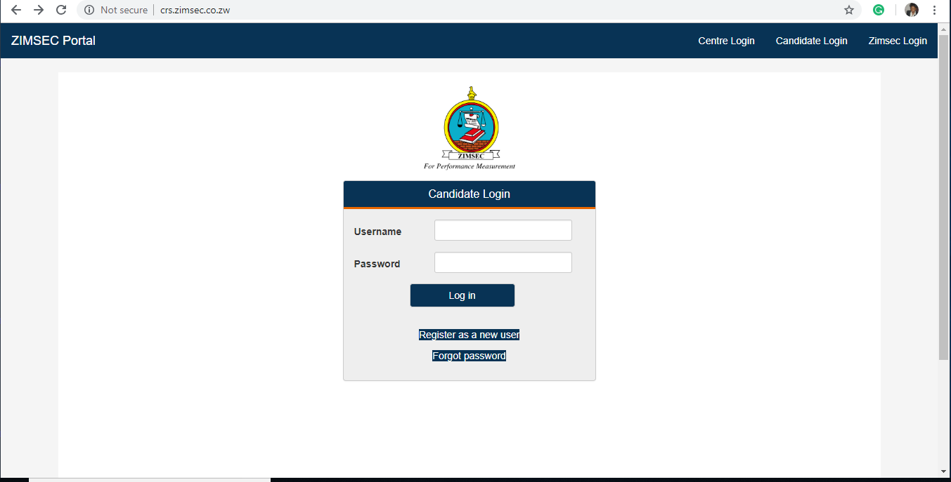

  - Click on Register New User the screen below will appear

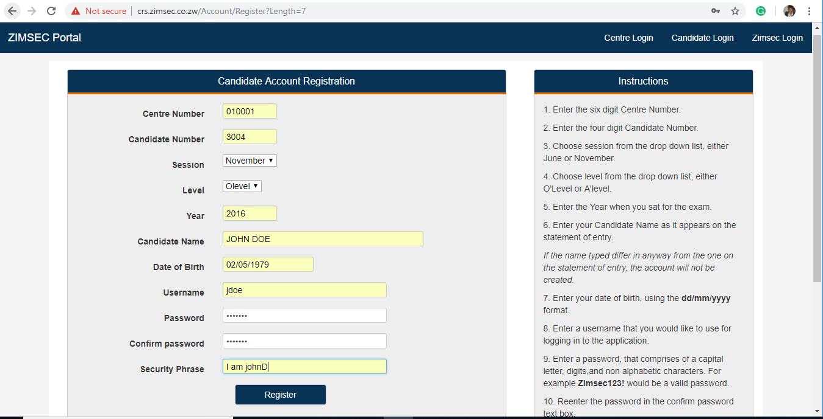

  - Instructions on user registration are listed on the right side of the screen NB ENTER CREDENTIALS AS THEY APPEAR ON THE ZIMSEC STATEMENT OF ENTRY!!!!
  - THE SECURITY PHRASE SHOULD BE AT LEAST 10 CHARACTERS (LETTERS)

- Candidate Login
  - Click on Candidate Login, A Login window appears as shown below where you need to specify your username and password
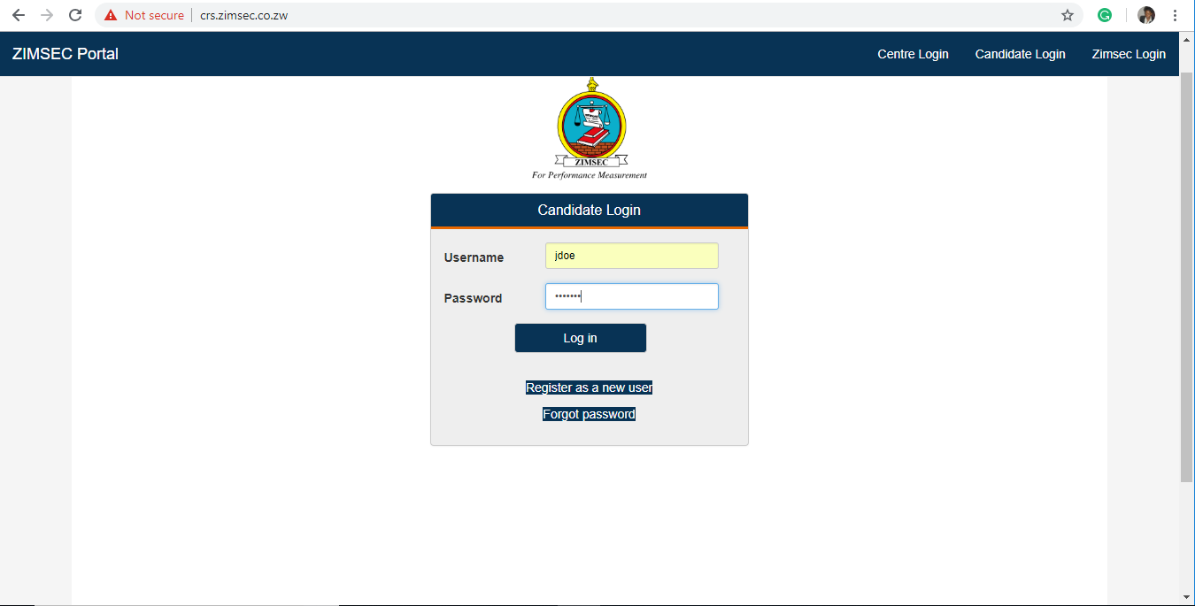

  - Enter Username and Password as created at user registration
  - Click on Login

- Upon successful login the Results portal screen as shown below pops up.
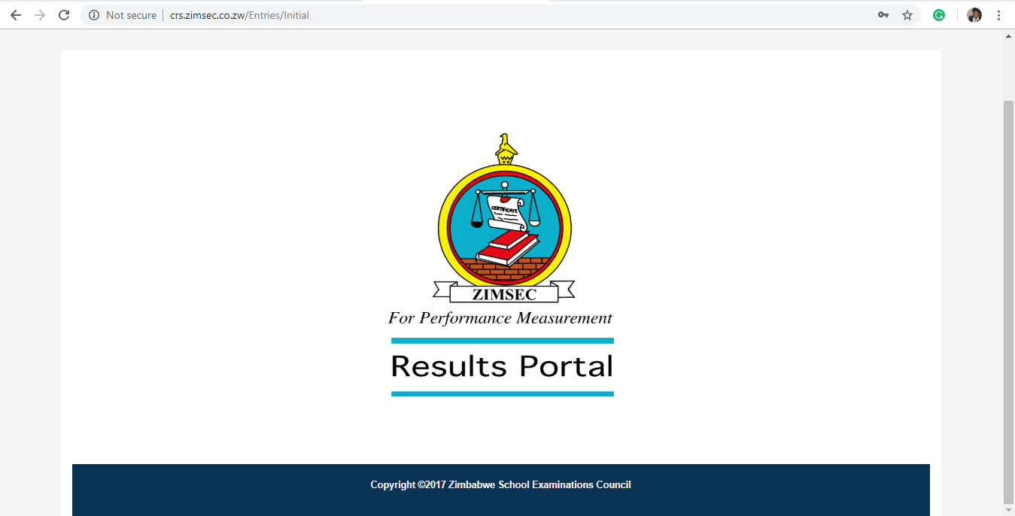

  - On the Results Portal Window there is statement of entry and Candidate Results Menu
  - Click on Statement of Entry , a user statement of entry will appear

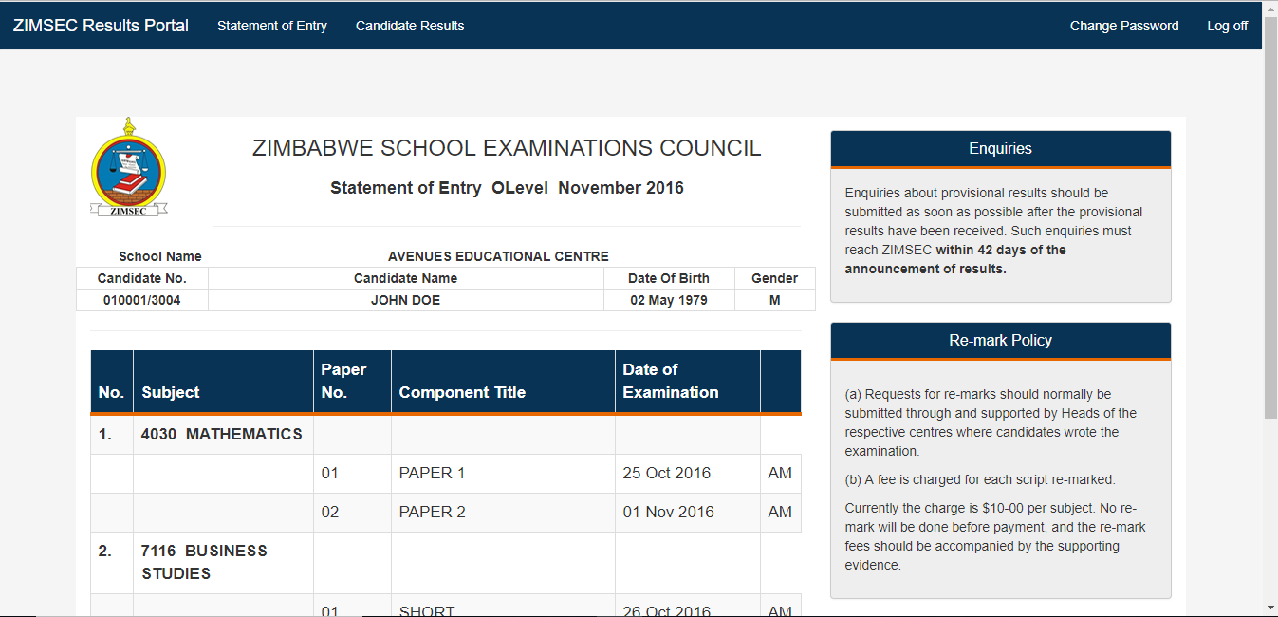

  - Click on the Candidate Results menu to view candidate results
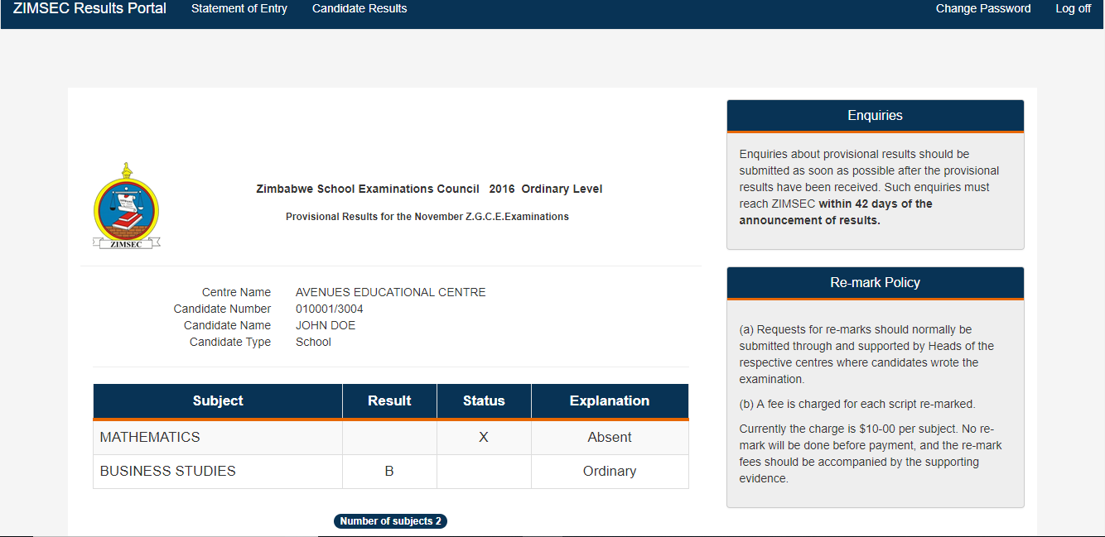

- Changing Passwords.
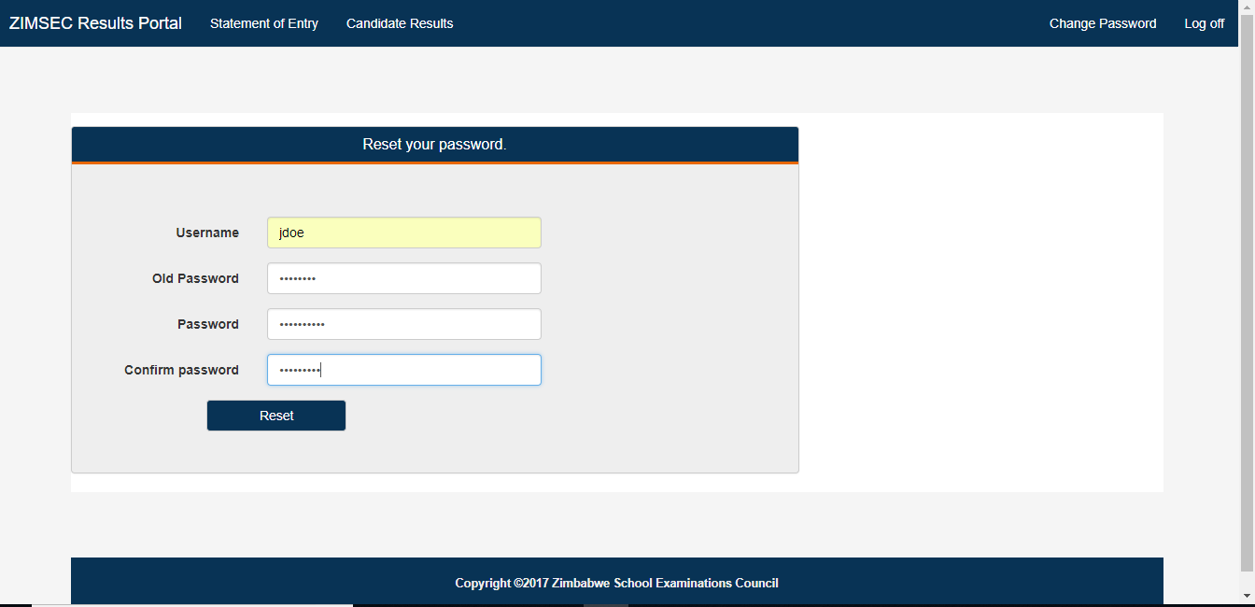

  - To change your password , Click on Change Password
  - Type in your username
  - Type in your current password in the field Old Password
  - Type in your new password
  - Retype the new password on Confirm Password
  - Click on Reset button to effect the change
- Centre Login
- For a centre to be login to the Results system a user needs to create an account
  - Click on Centre Login on the home screen, the screen below will appear
  - Click on Register as a new user

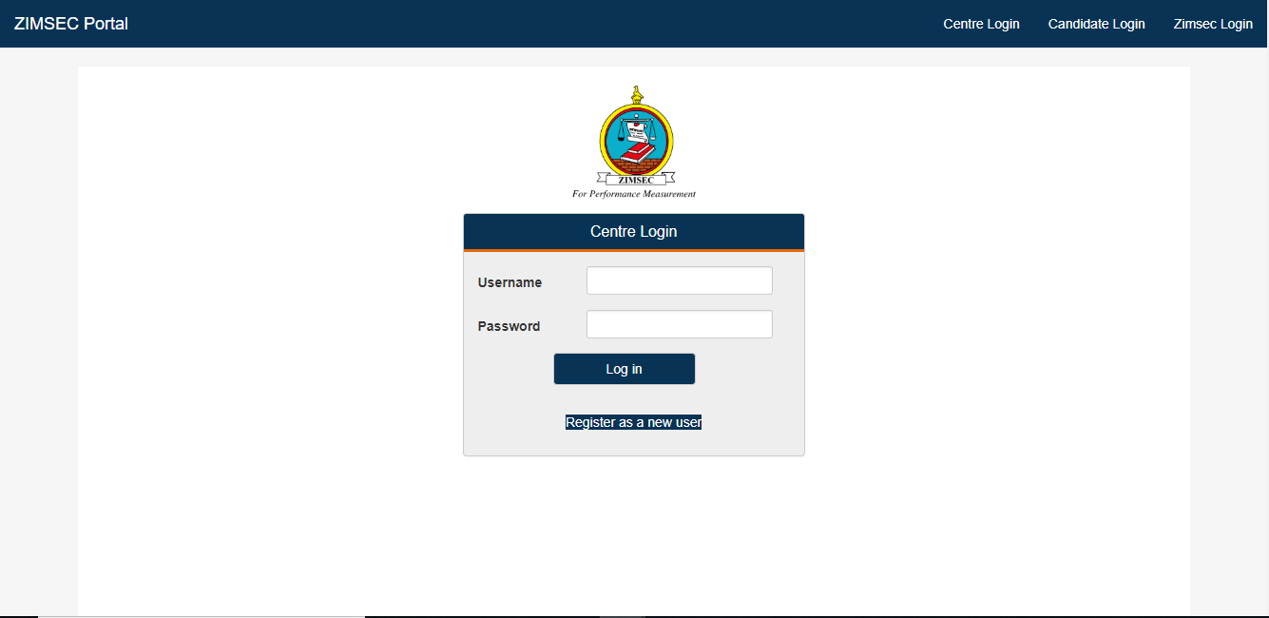

  - A screen below will appear
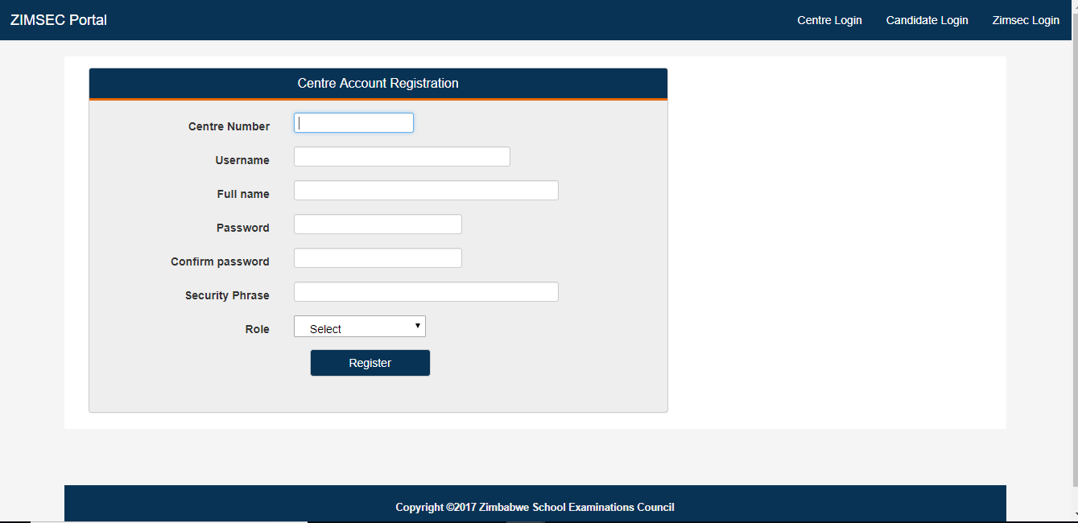
  - Type in your Centre number, Username, Full name, Password, Security Phrase in the fields provided (Username will be any name which a user will use to logon, A security phrase is an additional check measure to validate a user at logon)
  - A security phrase should be at least 10 characters long including spaces.
  - Click on the drop list menu to select your role either as a Centre Admin or an Ordinary system user
  - NB THERE CAN ONLY BE ONE CENTRE ADMIN IN THE SYSTEM , THE ADMIN ACCOUNT HAS TO BE ACTIVATED BY YOUR RESPECTIVE REGIONAL OFFICE UPON CREATION!!!!

- Upon successful creation of an account
  - Click on Centre Login, the screen below will appear
  - Enter Username and Password specified
  - Click on the Login button

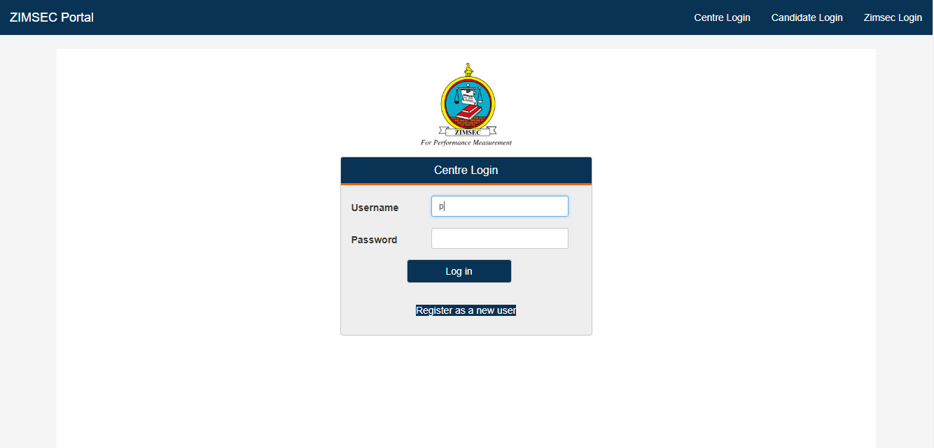

The Security Phrase Screen will popup
You are required to type in the characters in your security phrase at account creation according to the random positions specified.
I.e. I AM A HEADMASTER AT ........ as a security phrase will be typed as
- Position 4 is M
- Position 11 is D
- Position 20 is T
NB A space is considered as a character in your phrase!!!!
Click on Verify to proceed. Typing in wrong details of the security phrase bars a user from logging in.
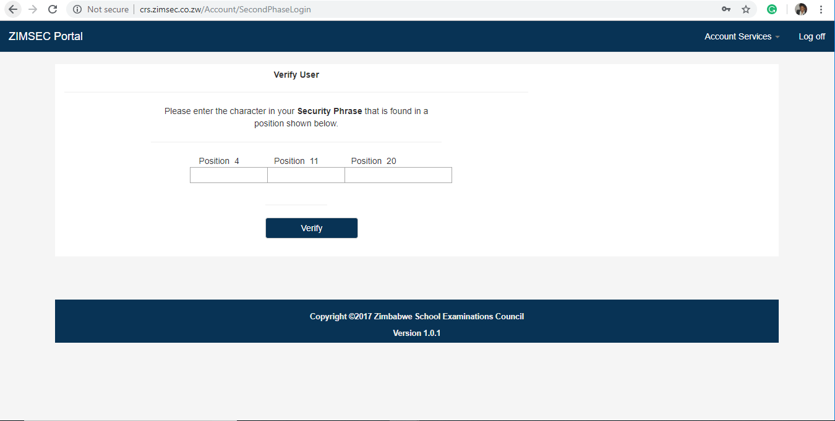
- Upon successful login in , the system takes you to the Home Screen
  - On the home screen menu there is the Candidates Results and the Candidates Grades by Subject options
  - Click on the Candidates Grades by Subject to view Subject Passes.

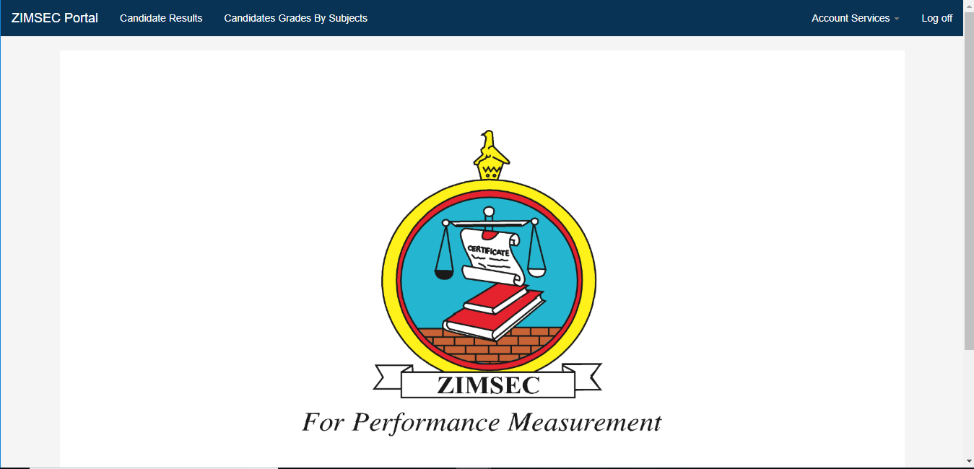

  - Click on the Candidate Results to View the list of all candidates at centre
  - Select Session, Level and Examination Year to pull out a list of Candidate Results

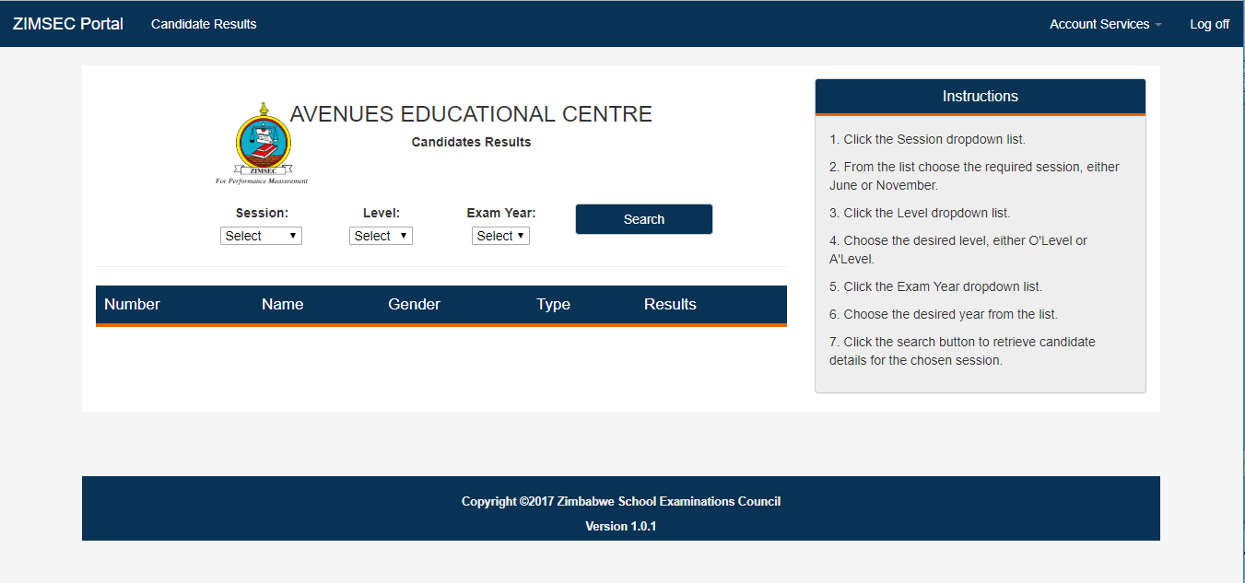

- Activation of User accounts
The Centre system Admin can activate users created to use the system on the window below
  - Click on Acount Services, a drop down Menu will appear
  - Click on Activate user to enable a user to access the system

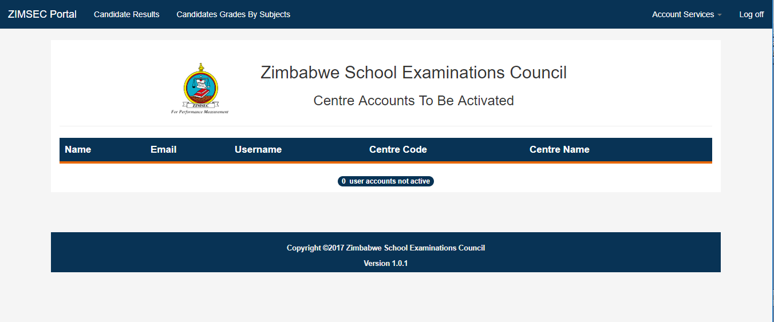
To view active users in the system
  - Click on Account Services and select Active Users, the same window can be used to Deactivate a user or Reset their passwords.
  - Click on Deactivate to disable a user account
  - Click on Reset to reset a user password

