**.**

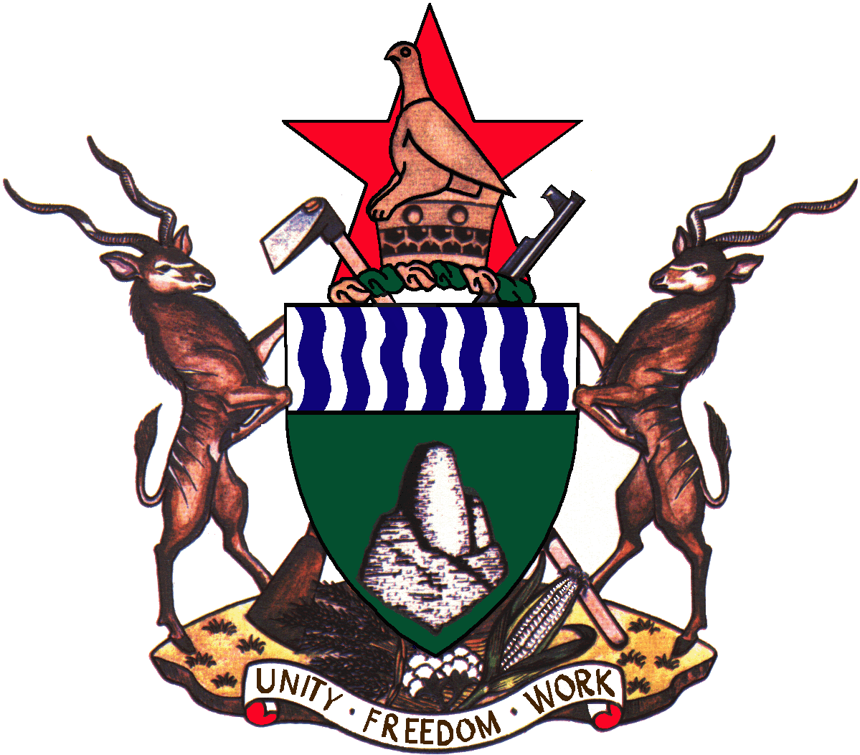

**Zimbabwe**

**“THE HIDDEN STORY OF ZIMBABWES ECONOMIC DEVELOPMENT”**

***KEY MILESTONES AND PROGRESS ON POLICY REFORMS***

**Ministry of Finance and Economic Development**

**October 2019**

CONTENTS

INTRODUCTION 3

Vision 2030 4

Steps to Vision 2030 5

Transitional Stabilisation Programme Thrust 6

PROGRESS ON TSP REFORMS 6

GOVERNANCE REFORMS 7

Alignment of Laws to the Constitution 7

Independent Constitutional Commissions 7

FISCAL CONSOLIDATION 9

TRADE AND CURRENT ACCOUNT 14

THE TSP AND STAFF MONITORED PROGRAMME 15

INFRASTRUCTURE REHABILITATION AND DEVELOPMENT 16

PUBLIC ENTERPRISES REFORM 24

EASE OF DOING BUSINESS REFORMS 26

Bilateral Investment Promotion and Protection 28

One Stop Shop Investment Centre 28

Special Economic Zones 29

Exchange Control Liberalisation 32

Compensation of Farmers 33

CHALLENGES 33

WAY FORWARD 35

# INTRODUCTION

1. Realising vast opportunities in natural resource endowments, high literacy rates, highly skilled labour force, developed basic infrastructure, a diversified but under-capacitated industry and the country’s strategic position within Southern Africa, the New Dispensation has come up with a Vision for rebuilding and transforming Zimbabwe into an *Upper Middle Income Economy by 2030*.
2. The opportunities are especially in the sectors of mining, agriculture, infrastructure, manufacturing and tourism. *Refer to Annex 2.*

**Opportunities for Leveraging Growth and Development**

### Vision 2030

1. The Vision 2030 is anchored on four clusters, which are: governance, macroeconomic stability and financial re-engagement, inclusive growth, infrastructure and utilities, social development and cross cutting themes.



1. The journey to an Upper Middle Income Status requires sustaining high growth rates averaging 7% per annum.

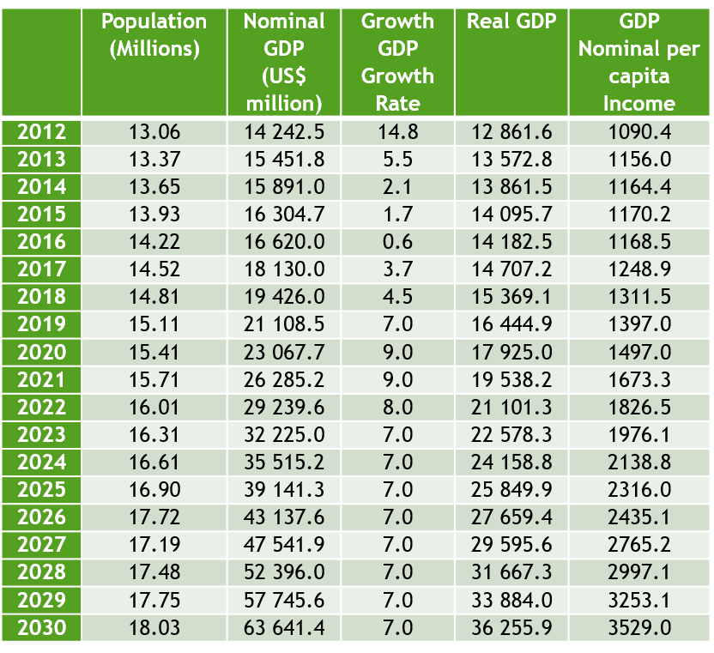

### Steps to Vision 2030

1. Realisation of Vision 2030 is through implementing the following programmes/plans:

* The Transitional Stabilisation Programme (TSP): September 2018 – December 2020;
* First Five year National Development Plan (NDP1): 2021-2025; and
* Second Five year National Development Plan (NDP2): 2026-2030.

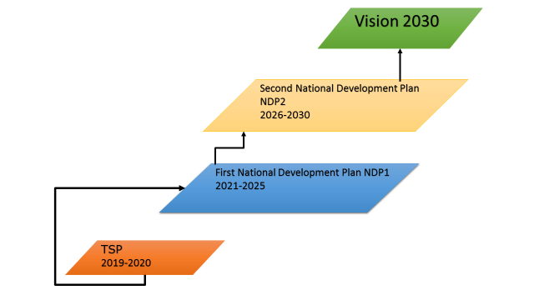

### Transitional Stabilisation Programme Thrust

1. Currently, Government is implementing the Transitional Stabilisation Programme (TSP), which focuses on stabilizing the macro-economy and laying a foundation for sustainable and shared private sector-led growth. Creating the necessary environment for investment and growth requires strengthening governance and normalising international relations.

# PROGRESS ON TSP REFORMS

1. Implementation of reforms outlined in the TSP is on course, with notable milestones on fiscal consolidation, monetary policy restoration, liberalisation of the foreign exchange market, structural and governance reforms, re-engagement, investment promotion and support for the productive sectors.
2. These reforms are at different levels of implementation but all present a strong foundation for economic rebound in 2020 and beyond.

## GOVERNANCE REFORMS

1. Government recognise the importance of transforming all governance systems including rule of law, freedoms of expression and association, respect for human and property rights, and zero tolerance to corruption, among others. Through step by step execution, progress has been made in the following areas:

### Alignment of Laws to the Constitution

1. An intensive Constitutional outreach programme winded off by a referendum of 16 March 2013, saw a new Constitution of Zimbabwe Amendment (No. 20) being adopted in May 2013. Consequently, an Inter-Ministerial Taskforce was established in 2015 to coordinate the alignment of laws to the new Constitution.
2. The process is meant to guarantee Constitutional provisions, fundamental rights and freedoms. Of the 206 Acts which required alignment, 159 Laws have been aligned. With consolidations and separations of some previous laws, about 65 laws require to be aligned during 2019-20.

### Independent Constitutional Commissions

1. Government has successfully established and operationalised all Independent Constitutional Commissions mandated to promote good governance. These are:

|  |
| --- |
| **Institution** |
| Zimbabwe Human Rights Commission |
| National Peace and Reconciliation Commission |
| National Prosecuting Authority |
| Zimbabwe Anti-Corruption Commission |
| Zimbabwe Electoral Commission |
| Zimbabwe Gender Commission |
| Zimbabwe Land Commission |
| Zimbabwe Media Commission |
| Judicial Service Commission |

1. In 2019, the Budget made an allocation of ZWL$202 million to these institutions for their operations and capacitation. Establishment of these Commissions have seen some progress in the areas of fighting corruption with many cases now being dealt with by ZACC, robust systems for planning and executing elections as demonstrated during the 2018 Harmonised General Elections, reconciliation and bringing together of different political parties to discuss national issues, through the Political Dialogue.

***Repealing of POSA***

1. Government approved the principles of the proposed Maintenance of Peace and Order Bill on 19 February 2019, which is repealing the Public Order and Security Act (POSA). By 3 September 2019, the Bill had gone through both houses of Parliament and is now awaiting Presidential assent.

***Repealing AIPPA***

1. Similarly, the Access to Information and Protection of Privacy Act [Chapter 10:27] is being repealed and will be replaced by:

* The Zimbabwe Media Commission Act;
* The Freedom of Information Act, and
* The Protection of Personal Information/Data Act.

1. Cabinet approved the Freedom of Information Bill and the Broadcasting Services Amendment Bill on 15 May 2019, which were subsequently gazetted on 17 June 2019. The two bills seek to provide the right to freedom of expression and freedom of the media. The Zimbabwe Media Commission Bill was also gazetted on 9 August 2019 and will go through Parliamentary processes during the Second sitting of Parliament, starting 1 October 2019.

***Reforms of the Police Force***

1. Government is reforming the Police force in order to restore its appropriate mandate and enhance its effectiveness in ensuring the rule of law in the country. Accordingly, the Police Amendment Bill to align the Act to the Constitution is being processed. ZPS has started retraining its officers so that they conduct their duties in a professional manner.

## FISCAL CONSOLIDATION

1. Previous three-five years were marked with growing fiscal deficits due to fiscal indiscipline emanating from failure to adhere to approved Budgets, with significant expenditures being incurred arbitrarily outside Budgeted Votes, and failure to follow laid down systems, at times involving quasi-fiscal expenditures.

**Managing Budget Deficits**

1. With the inception of the TSP, fiscal policy now targets a budget deficit in line SADC threshold of below 5% of GDP. As a result, Government has been rigorously implementing fiscal consolidation measures directed at containing expenditures while strengthening revenue collections (e.g introduction of 2% Intermediated Mobile Transfer Tax).
2. Expenditure containment measures, particularly focussed on:

* An end to recourse to Central Bank financing including the overdraft,
* Issuance of TBs only for Budgeted expenditures,
* Maintaining public wage bill below 50% of total expenditures with adjustments linked to cost of living (COLA) parameters,
* Rationalisation of posts and freeze on hiring, save for critical sectors/posts
* Enforcing Retirement Policy by retiring staff who have reached the retirement age of 65 years, those without the required qualifications and voluntary retirement;
* Removal of duplications of posts in various ministries; and
* Removal of a number of benefits, including personal issue vehicles, fuel allocations.

1. Consequently, Budget savings are being realised in 2019. These savings are being treated as a buffer for meeting exigencies such as impact of Cyclone Idai and drought. They also provide scope for increased spending on social services, social protection, and infrastructure development**.**

***Supportive Monetary Policy***

1. The multiple currency regime served its purpose in stabilising the economy through dampening inflation. However, the monetary system lacked flexible utilisation of a full set of monetary instruments to influence economic activity. In addition, the adoption of a hard and strong currency such as the US$, compromised competitiveness of local companies.
2. It is with this view that Government took a deliberate gradual approach for transiting from the multiple currency system to mono-currency through the following steps:

* Separation of the foreign Nostro accounts from RTGS denominated accounts as announced during the October 2018 Monetary Policy Statement;
* Establishment of the RTGS dollar comprising of electronic balances in banks and mobile platforms, bond notes and coins as announced during the Monetary Policy Statement of 20 February 2019 (SI 33 of 2019);.
* Introduction of the Zimbabwe dollar on 24 June 2019. Under the new framework, all domestic transactions are now settled in Zimbabwe dollars, the sole legal tender represented by bond notes and coins and electronic currency, that is, RTGS dollars. All other currencies from the multi-currency regime serve as reserve currencies.

1. The gradual strengthening of the Monetary Policy was meant to restore domestic competitiveness and promote growth, remove price distortions in the foreign exchange market, improve export competitiveness through sale of export proceeds at market determined rates.
2. The new policy was further buttressed by the following measures:

* Appropriate adjustment of the overnight interest rate to manage speculative borrowing,
* Removal of administrative bottlenecks to efficient functioning of Bureau De Changes ;
* Managing activities on the Zimbabwe Stock Exchange to deal with unethical transactions, for example Government placed a vesting period of 90 days for dually listed shares;
* Mopping up excess liquidity; and
* Establishment of a Monetary Policy Committee and appointment of a New RBZ Board.

1. As a result there is some return of normalcy on the exchange market, with the exchange rate volatilities being reigned under an average exchange rate of 1USD: 15 Z$.



1. Further regulatory measures are being instituted on mobile transactions in order to check on unethical and money laundering practices.

*Outlook*

1. Continued implementation of macro-fiscal stabilization measures are expected to stabilize the foreign exchange market and inflationary pressures.



## TRADE AND CURRENT ACCOUNT

1. The current account, for the first time since the adoption of the multi-currency regime in 2009, registered a surplus of US$196 million in the first quarter of 2019. This was due to the impact of import management measures under implementation, which prioritise capital and production inputs as opposed to non-essential finished goods.

Current Account US$M

## THE TSP AND STAFF MONITORED PROGRAMME

1. The Government has signed off on a Staff Monitored Programme (SMP) with the International Monetary Fund (IMF) covering the period May 15, 2019 to March 15, 2020. The SMP seeks to assist Zimbabwe implement key reforms as outlined in the Transitional Stabilisation Programme (TSP) that way allowing the country to build a track record of sound economic policies as it seeks to reengagement with the international community.
2. The monitoring of the SMP will be through 3 reviews – end June 2019, end September 2019, and end December 2019 based on 6 quantitative benchmarks and 9 structural benchmarks.
3. As at end June 2019, Government met 4 out of 6 quantitative targets and missed the target on Floor on stock of international reserves and ceiling on credit to the nonfinancial public sector from the RBZ. The target on reserves was missed by US$507 million reflecting excessive borrowing necessitated by imports of critical goods and services e.g. fuel, electricity, drugs, wheat, etc.

**ZIMBABWE - QUANTITATIVE TARGETS**

|  |  |  |  |  |  |
| --- | --- | --- | --- | --- | --- |
|  | June Actual | Jun  Prog. Target | Sep  Prog. Target | Dec  Prog. Target | Comment |
| 1. Floor on primary budget balance of central government (ZWL$ million) | 188.3 | -1,203 | -1,604 | -2,005 | Target for June met. |
| 1. Floor on protected social spending (ZWL$ million) | 258 | 225 | 500 | 750 | June Target met.  As of end June 2019, **$258 million** was spend. Education – 30.1 million, health 88.6 million and Social protection 138.7 million. |
| 1. Floor on the stock of official international reserves (US$ million) | -1 774 | -1267 | -1267 | -1267 | June actual position missed the target by US**$507 million**. Additional borrowings were necessitated by imports of critical goods and services e.g. fuel, electricity, drugs, wheat, etc. |
| 1. Continuous ceiling on stock of new non-concessional external debt contracted or guaranteed by the general government with original maturity of one year or more (US$ million). | **0** | 0 | 0 | 0 | June target met.  The US$113 m is not new debt but a draw-down from the signed loan agreement. |
| 1. Ceiling on changes in Net Domestic Assets of the RBZ   (ZWL$ million) | -19.83 | 300 | 350 | 400 | June figures are within range. The figures have been adjusted for exchange losses, as required by the IMF. |
| 1. Ceiling on credit to the nonfinancial public sector from the RBZ (ZWL$ million) | 161.65 | 0 | 0 | 0 | The June target was missed by $161.65, due to RBZ lending to its subsidiary, Fidelity Printers & Refiners (FPR) under the Gold Development Initiative, which is earmarked to increase foreign exchange in the economy. |

1. In June 2019, Government has one structural benchmark relating to ‘Adopting regulations implementing the Public Financial Management (PFM) Act including ensuring that all expenditure commitments are recorded in IFMIS’. The regulations were gazetted on 14 August 2019 and hence target was met.
2. Successful implementation of the SMP, in conjunction with key reforms in the TSP will enhance development partners and creditors support. The strong support from creditors will be crucial for the rapid implementation of a comprehensive arrears clearance and debt relief program.

## INFRASTRUCTURE REHABILITATION AND DEVELOPMENT

1. Good infrastructure is a prerequisite for achieving economic growth and development through enabling other sectors of the economy to function efficiently and effectively.
2. The country’s infrastructure has gone for decades without meaningful maintenance, creating a huge gap. In order to close the gap, Government has embarked on a number of infrastructure projects in various sectors and many are at various stages of implementation as indicated below:

| Sector | Projects | Achievements | Outstanding Works |
| --- | --- | --- | --- |
| POWER | **Hwange Power Station 7 & 8** | 21% complete   * Main powerhouse foundation and civil works * Transmission lines rout clearance * Electro-mechanical equipment design | * E & M Warehouse Construction, Batching Plant, Construction Chimney & cooling water forebay foundation |
| **Kariba Dam Rehabilitation** | * Contract signed on 24 May 2019 between Zambezi River Authority & the successful bidder; * Plunge pool works commenced; and * Dam break analysis field surveys done. | * Programme implementation to take four years |
| **Batoka Gorge Hydro-Electric Project** | * Contract awarded to a consortium of Power China and GE Electric. * Contractor submitted proposal. | * Negotiation with consortium in progress for final agreement |
| **Rural Electrification** | * 8 institutions electrified, * 87 grid extensions and 5 biogas digesters completed | * 148 grid extensions and 5 biogas digesters projects outstanding |
| WATER | **Marovanyati Dam** | * Construction of the outlet tunnel is complete. * Outlet Works Concrete now complete. * Spillway Excavations now at 90%. * Rehabilitation of Site Infrastructure is at 97%. * Installation of hydro-mechanical equipment * Overall Progress now at 96% | * Main dam completion, spillway, outlets, compensation and resettlement costs. |
| **Gwayi-Tshangani Dam** | * Pump house and Powerhouse Excavations 0%. * Dam, spillway and apron concrete 8.7 * Outlets Concrete 0% * Grouting in progress | * Main dam and spillway. |
| **Chivhu Dam** | * Site establishment is at 50%. * Clearing and stripping on the main dam foundation area is at 48%. * Clearing on the borrow areas is at 22%. * Original ground level survey on the main dam is at 100%. * Construction of main access road (gravel surface) is complete. * Original ground level survey of the proposed site for the water treatment plant is at 100%. | * Grouting, outlets and main dam |
|  | **Causeway Dam** | * Outlet encased pipe concrete placing remains at 80%. * Embankment placing right bank saddle dam is at 90%. * Embankment placing left bank saddle dam is at 97%. * Grout drilling for grout stand pipes * Drilling and blasting boulders on river bed section. | * Main dam completion, spillway, outlets, compensation and resettlement costs. |
| TRANSPORT | ***Roads***  **Hre-Beitbridge Road** | * Beatrice Section 3km detour constructed and opened to traffic, Second 3km detour under construction, 3km road rehabilitation now at base 1 | * Beatrice Section   Completion of second 3km detour  3km of base 1 construction and surfacing on rehabilitation section |
|  | * Chivhu Section * 4.2km detour constructed and opened to traffic * 5km completed on second detour 1.2km of the 4.2km, rehabilitation section completed to base 2, further 3km completed to base 3 | * Chivhu Section   1km of second detour construction  3km base 2 and 4.2km  base 1 and surfacing on the rehabilitation section |
|  | * Contracting   6 Contractors secured for the construction of 6x20km sections, now at contract signing stage   * Works to commence by 15 November 2019 | * Contracting * Rehabilitation of 120km of road |
| **Hre- Bulawayo Road** | * 5km completed and primed for surfacing | * 5km surfacing   Shelvert and access roads construction |
| **Harare-Mutare Road** | * 4km completed to base 3 | * 1km full construction   4km of base 2 and base 1 construction and surfacing |
| **Rural Feeder Roads** | * Road grading 7855km | 1245km road grading |
| * Rehabilitation of roads (805km) and bridges (39) completed. | 415km Cyclone Idai damaged and other feeder roads. |
| * National Parks roads 190km completed | 180km road rehabilitation |
| * Karoi-Binga road upgrading 10km base 1 and 2 completed. | * Tarring 10km (Tack and Seal). |
| ***Aviation*** |  |  |
| **R.G. Mugabe Airport** | Excavations for arrivals and departure extensions completed | Civil works on the runway |
| SOCIAL SERVICES | **Construction of 17 rural schools with co-financing from OFID** | * 17 schools completed (6 secondary and 11 primary); * Mariga Primary School and Kotwa ECD block competed | * Electrification, furnishing and equipping of the 17 schools |
| **Construction of 17 rural schools with co-financing from OFID** | * Procurement of furniture, computers and equipment underway | * Electrification of schools |
| **Innovation Hub** | * Completed 4 Innovation Hubs at University of Zimbabwe, Midlands State University, National University of Science and Technology and Chinhoyi University of Technology. | * Equipping of all the Innovation Hubs laboratories and completion of innovation hub at Harare Institute of Technology. |
| ***Health Infrastructure*** |  | |
| **Health Posts** | * Construction of health posts main structures completed at Dundwe, Minda, Kairezi and Gumbochuma | * Construction in progress for health posts ablution, water and waste management facilities at the 4 health posts outstanding. |
| **Refurbishment of District Hospitals** | * Refurbishment of general wards and water & sanitation facilities at Mvurwi, Kadoma and Ndanga District hospitals completed. | * Painting of exterior walls, refurbishment of kitchen, laundry and incinerator on going. |
| **Provincial Hospitals** | * Refurbishment of Gweru Provincial Hospital completed | * Refurbishment currently on-goimg at Mutare and Masvingo Provincial Hospitals |
| * Revaluation, recontracting and remobilisation by the contractor completed for the resumption of the construction of Lupane Provincial Hospital | * Work on the administration Office and OPD and pharmacy block outstanding |
| **Central Hospitals** | * Refurbishment of wards and theatres at UBH and Mpilo completed’ * Mbuya Nehanda Maternity Hospital also completed. * Excavation works on UBH medical laboratory completed. | * Rehabilitation of Chitungwiza School of Nursing and water reservoir on-going. * Water reservoirs at Harare Central and UBH not yet complete. |
| **Rural Health Centres** | * Construction of main clinic blocks at Dongamuzi, Munemo, Chiromo and Mbuyamaswa on-going. | * Construction works |
| ICT | **Optic Fibre Communications Infrastructure Network** | * Laying of optic fibre completed on: Harare-Mutare, Harare-Bulawayo, Bulawayo-Beitbridge, Harare-Beitbridge, Upgrade of Northern ring i.e. Harare, Mazoe, Glendale and Concession, Makuti-Chirundu, Bulawayo-Plumtree, Bulawayo-Matopo, Macheke-Murehwa, Nyazura-Murambinda, Harare-Chinhoyi-Kariba, Mashava-Masvingo, Gweru-Masvingo, Harare-Chitungwiza, Harare Metro ring, Bulawayo Metro ring, Mutare-Odzi | * Harare-Machipanada, Bulawayo-Victoria Falls, Kadoma-Gokwe, Harare-Nyamapanda, Mutare-Nyanga-Hauna |
| **Base Station/Towers** | * 22 shared base stations deployed | * 328 shared Base stations |
| **Expansion of PFMS** | * 6 Kiosks Completed * 63 District hospitals (Grants Management) * Modernisation of PFMS Data Centre (Primary and Secondary) * PFMS ZIMRA Interface * 7 Training Centres connected on PFMS | * 57 Kiosks * Roll out to all Govt Funds and Grants institutions * Business Intelligence(BI), Business Planning and Consolidation (BPC) * 9 Training centres |
| **Community Information Centres** | * 110 CICs deployed and 4 Containerised Village Information Centres operational | * 186 CICs |
| **National Data Centre** | * Renovations completed | * Installation of Servers and migration of systems |
| **SMART Government** | * Human Capital Management System (PSC), Deeds, Liquor Licensing, ZIA, and Chitungwiza Hospital (4 flagship projects) * 80 Online services * Govt Private Cloud (Covering all provincial capitals, district hospitals and PFMS kiosks) | * 5 flagships * 50 online services * Paperless Cabinet * E-Health Call centre * ICT National Call Centre * All MDAs not connected on the cloud |
| **Zimbabwe Digital Migration Project** | * Head-end equipment installed & completed | * 11 Television Transmitter Sites |
| **Broadcasting Migration Project** | * 18 Existing TV Sites completed * New Transmitter Sites 12 done * TV Studios; 2 completed at Pockets Hill | * 7 New Site Tower Material * 10 FM Transmitter Sites Renewal * 4 TV Studios completion * 4 Radio Studios Completion * Equipping of 2 OB Vans & 2 DSNG Vans * 7 Foundations * 7 Tower replacement * 7 New Towers * 5 Gap Fillers |
| HOUSING | **New Parliament Building** | * Superstructure is at third floor deck level | * Completion of the superstructure, electrical works, plumping, civil works, partitioning, carpentry and room loading |
| **Construction of Chinhoyi court** | * Super structure complete * Roofing complete * Plastering 95%complete * Electrical 80%complete | * Soil cutting, tiling, paneling, painting and furnishing |
| **Construction of Mt Darwin court** | * Super structure complete * Procurement of roofing material was done | * Roofing, plastering tiling, paneling, * Painting and furnishing |
| **E-justice system** | * Tender was approved by PRAZ | * Procurement of machines and other ICT equipment * Establishment of connections through vpn for phase 1 * Constitutional court * Supreme court * Commercial court |
| **Acquisition rehabilitation of commercial court** | * The building was purchased and is undergoing customization. | * Customization of the building. * Painting, tiling and furnishing |
| **Acquisition rehabilitation of master of high court Bulawayo** | * The building was purchased and is undergoing customization. | * Customization of the building. * Painting, tiling and furnishing |
| **Construction of Gwanda court** | * Procurement of super structure material was done | * Construction of the super structure |
| **Construction of Lupane Court** | * Procurement of super structure material was done | * Construction of the super structure |
| **Construction of Epworth Court** | * Procurement of super structure material was done | * Construction of the super structure |
| **Construction of Murehwa Court** | * Procurement of super structure material was done | * Construction of the super structure |
| **Construction of Chiredzi Court** | * Procurement of super structure material was done | * Construction of the super structure |
| **Tomlison Flats** | * Block B comprising of 32x3 Bed Units supper structure completed | * Electrical, plumping, painting |
| * Block C2 comprising of 16x3 Bed Units-substructure and brick work ground floor completed | * Brickwork first floor to 3rd floor |
| **Kazungula 2 Bed Bachelor Flats** | * Feasibility study completed by MoLGPWNH * Tendering process completed | * Commencement of construction works |
| **Vic Falls 3 Bed Bachelor Flats** | * Feasibility study completed | * Commencement of construction works |
| **Plumtree 3 Bed Flat** | * Feasibility study completed | * Commencement of construction works |
| **Mutare 2 Bed Fats** | * Feasibility study completed | * Commencement of construction works |
| **Goromonzi District Registry** | * Construction works at window level | * Completion of structure and brickwork * Roofing, Plastering, plumbing, painting |
| **Hwedza District Registry** | * Construction works at window level | * Completion of structure and brickwork * Roofing, Plastering, plumbing, painting |
| **Insiza District Registry** | * Construction works at window level | * Completion of structure and brickwork * Roofing, Plastering, plumbing, painting |
| **Kadoma District Registry** | * Construction works at window level | * Completion of structure and brickwork * Roofing, Plastering, plumbing, painting |
| **Prisons Staff Houses** | * Completed 60 staff houses | * To complete 102 staff houses and 2 barracks that are at different stages of completion which require roofing, plumbing, electrical, painting and glazing works. |
| * Renovated Kariba Prison roof. | * Works are still underway at Mutimurefu Prison cellblock and Whawha Medium cellblock. * Mutimurefu cellblock was affected during cyclone idai while Whawha Medium cellblock roof was blown off by hailstorm. * We have not started working at Chinhoyi Prison roof that was affected by termites. |

## PUBLIC ENTERPRISES REFORM

1. Government has embarked on a programme to reform public enterprises in order to improve their efficiency and governance, that way, increasing their contribution to the economy. The following Government decisions were made:



1. For 2019, Government has targeted 5 public enterprises, namely Tel-One/Net-One, ZIMPOST and POSB for immediate reforms, and progress is as follows:



## EASE OF DOING BUSINESS REFORMS

1. Government, continues to pursue Ease of Doing Business Reforms as part of broad measures on enhancing the country`s investment environment and external competitiveness. The reforms target administrative and other legislative bottlenecks under various statutes.
2. With regards to administrative procedures, timelines and costs have been reviewed and streamlined to facilitate the Ease of Doing Business. The 2019 World Bank Doing Business Report identified Zimbabwe as one of the top 20 on the world and top five in Africa doing business reformers. The country was noted to have made improvements in the five areas of:

|  |  |  |
| --- | --- | --- |
| Issue | Previous Challenge | New Timelines/Procedures |
| Starting a Business | 32 Days | 11 Days |
| Harare Municipality fees | US$300 | RTGS$3 000(Approx US$200) |
| Dealing with Construction Permits | 208 Days | 150 Days |
| Registering of property | 36 Days | 14 Days |
| Enacting of relevant Acts |  |  |

*Legislative Milestones*

1. Government amended the following laws:

|  |  |
| --- | --- |
| Act | Main Objective |
| Deeds Registry | Facilitates the use of an online deeds registry and streamlines the process. |
| Shop Licenses Amendment | Streamlines processes for compliance with post registration regulations for businesses. |
| Estate Administrators Amendment | Introduces eligibility criteria and a robust code of conduct to ensure accountability of insolvency practitioners. |
| Judicial Laws Ease of Settling Commercial Disputes | To facilitate the settlement of certain suits or actions, especially suits or actions of a commercial nature. |
| Movable Property Security Interests | Facilitate the use of movable properties as security for borrowing and enables the creation of the collateral registry. |
| Public Procurement and Disposable of Public Assets | Abolish the State Procurement Board and set up a new body to be called the Procurement Regulatory Authority of Zimbabwe which will oversee and regulate procurement activities conducted by government Ministries, statutory bodies (parastatals) and local authorities. |

**Being Processed in 2019**

|  |  |
| --- | --- |
| Act | Main Objective |
| Zimbabwe Investment Development Agency | To facilitate the establishment of the one stop shop investment centre. |
| Manpower Act Amendment Bill & NSSA Act Amendment | Permit the centralization of collection of manpower development levies NSSA Obligations and PAYE and thereby streamline payments under the Paying Taxes indicator |
| Regional Town and Country Planning Act Amendment Bill | Streamline processes for Construction Permitting. |
| Enactment of the Companies and Other Business Entities | Facilitate starting a Business and Protection of Minority Investors |

### Bilateral Investment Promotion and Protection

1. Zimbabwe reiterates its commitment to ensuring that all foreign investments are safe and will honour its obligations under the various BIPPAs.
2. The country signed and ratified 12 Bilateral Investment Promotion and Protection Agreements (BIPPAs) with Denmark, Germany, Switzerland, Netherlands, China, India, Russia, Kuwait, Iran, South Africa, Yugoslavia and the OPEC Fund.
3. Signed BIPPAs awaiting ratification total 20, while a further 23 BIPPAs are being negotiated.

|  |  |
| --- | --- |
| Ratified | In the Pipe Line |
| Denmark, Germany, Switzerland, Netherlands, China, India, Russia, Kuwait, Iran, South Africa, Yugoslavia and the OPEC Fund | Czech, Sweden, Korea Republic, USA, Malaysia and Thailand |

1. Where violations were made with regards to land under BIPPAs, Government is engaging the respective parties, with a view to reaching amicable settlements.

### 

### One Stop Shop Investment Centre

1. The establishment of a One Stop Shop Investment Centre has been receiving urgent attention under the 100 Day Rapid Results Plan and as part of the priority investment reforms.
2. The Zimbabwe Investment Authority is being merged with the Special Economic Zones and the Joint Venture Unit to establish a One Stop Shop Investment Centre (Zimbabwe Investment Development Agency).

### Special Economic Zones

1. Government is moving with times in accelerating the implementation of this important investment programme capable of increasing exports, creating employment, as well as transferring technology and managerial skills.
2. The focus is on the initially designated pilot zones which are:



1. In support of this initiative, Government has gazetted incentives for SEZs investors.

**Incentives for Special Economic Zones in Zimbabwe**

|  | Incentive Area | Incentives |
| --- | --- | --- |
|  | FISICAL INCENTIVES- GAZZETTED | |
| 1. | Corporate Tax | Zero-rated Corporate Income Tax for the first 5years of operation with a corporate tax rate of 15% applying thereafter. |
| 2. | Customs Duty on Capital Equipment | Duty free importation of Capital equipment |
| 3. | Special Initial Allowance | Special Initial allowance of 50% of cost from year one and 25% in the subsequent two years |
| 4. | Employee’s Tax | Exempted |
| 5. | Non-Residents Withholding Tax on Fees | Exemption from Non-residents tax on fees on services that are not locally available. |
| 6. | Non-Residents Withholding Tax on Royalties | An exemption from Non-residents tax on Royalties. |
| 7. | Non-Residents Withholding Tax on Dividends | Exemption from Non-residents tax on Dividends. |
| 8. | Customs Duty on Raw Materials | Inputs which include raw materials and intermediate products imported for use by companies set up in the SEZs be imported duty free. The duty exemption will, however, not apply where such raw materials are produced in Zimbabwe. |
| 10. | Capital gains tax | Zero rated Capital gains tax. |

**INCENTIVES FOR SPECIAL ECONOMIC ZONES IN ZIMBABWE NOT GAZZETTED**

| Incentive Area | | Incentives |
| --- | --- | --- |
| NON-FISCAL INCENTIVES NOT GAZZETTED | | |
| 1. | Ownership | Ownership of companies within SEZs is up to 100% |
| 3. | Citizenship to Investors | Any person who invests more than US$500 000 and resides in Zimbabwe for more than 5 years will get Zimbabwe citizenship |
| 6. | Work permits for Expatriates | Issuance of work permits within 72 hours for 10 years |
| 7. | Residence Permits | Issuance of Residence Permit after (5) years |
| 8. | Water and Energy Supply | Dedicated Power, Water reticulation and sewer works for companies operating in Special Economic Zones |
| 9. | One Stop Shop investment Service | One Stop Shop investment services for all SEZs. |
| 10. | Review of Prospectus by EMA | Investors in the SEZ to be issued with Preliminary Development Permits within 5 days to allow resource mobilisation while finalising the EIA study. |
| 11. | Environmental Impact assessment (EIA) Approval | Environmental impact assessment to take less than 8 days. |
| 12. | Collaboration with Universities | Facilitated Research and Development |
| 14. | Visa fees for investors | Visas on entry if invited |
| 15. | Protection of Property Rights | Guaranteed |
| 16. | Labour Laws | Flexible |
|  | **Monetary Incentives** | |
| 18. | Capital and Profit repatriation. | 100% repatriation |
| 19. | Offshore borrowing | Investors allowed to borrow offshore without RBZ approval |
| 20. | Primary Bond issue Subscription | 100% Subscription |
|  | **Incentives for SEZs Developers** | |
| 21 | Land tenure | Developers are given 25 year leases for state land subject to renewal |

## Exchange Control Liberalisation

1. Zimbabwe has competitive Exchange Control Regulations, with a fully liberalised Current Account and partially liberalised Capital Account.
2. Foreign investors can freely remit investment income such as dividends and profits realised from their investments to various destinations without seeking prior Reserve Bank approval.
3. Requests to remit investment income to external destinations are handled at commercial banks without coming to Reserve Bank.
4. Similarly, foreign investors divesting from Zimbabwe can remit their initial capital, plus appreciation proceeds.

## Compensation of Farmers

1. Government has committed to finalising outstanding compensation obligations to all former farm owners affected by Land Reform Programme as enshrined in the Constitution and in line with BIPPAs.
2. As a result, during the year 2019, progress has been made in engaging the former commercial farmers to reach consensus on the global compensation figure for developments on farms.
3. Going forward, Government, through the National Budgets will continue to make provisions for compensation, while also engaging development partners on alternative ways of mobilising more resources to conclude compensation under the Land Reform Programme.

# CHALLENGES

1. The year 2019 faced a number of headwinds which derailed strides in reforming and turning around the economy. Severe exogenous shocks related to climate change caused drought and cyclone, which compromised agriculture activities and electricity generation with extended effects on other sectors.
2. These shocks were compounded by some macro-economic instabilities coupled with some foreign currency shortages in an environment of sanctions.

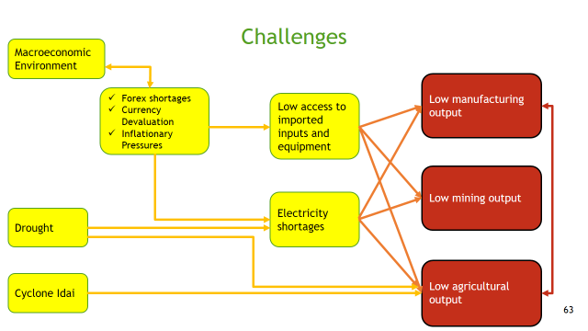

1. As a result, the economy was forced into a recession, with GDP growth revised projection pointing to a decline of around 6%.

**GDP Growth: 2019-20**

# WAY FORWARD

1. Building on the accomplishments of the ongoing reform agenda, Government will take advantage of positive strides made on stabilization to consolidate and gradually exit from austerity measures by switching to reforms that emphasise on growth, productivity and prosperity objectives. This means taking the economy to higher levels that focus on enhanced production and productivity, jobs creation, strengthening competitiveness and inclusive participation and empowerment.

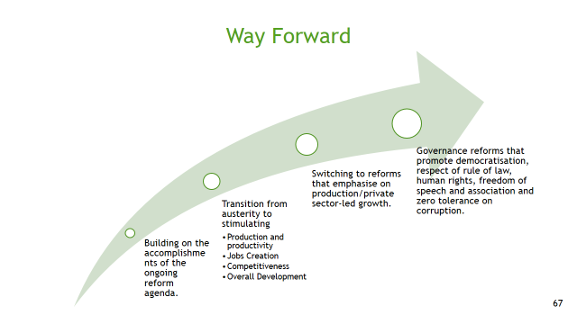

1. This will constitute the last leg of the TSP and transition to the Five Year Development Plans towards Vision 2030.

**Minister of Finance and Economic Development**

***October 2019***

**ANNEX 1: GENERAL INFORMATION ABOUT THE COUNTRY**

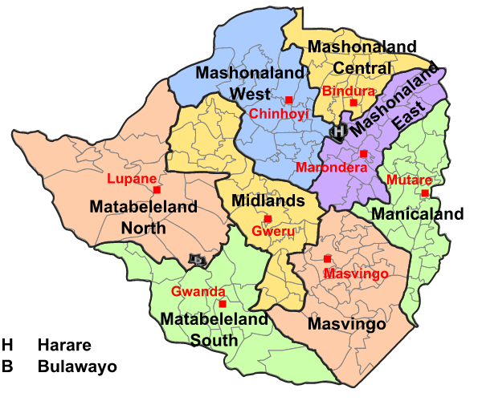

**Zimbabwe: Some Key Facts**

|  |  |
| --- | --- |
| Location | Southern Africa, at the heart of the North-South Corridor, making Zimbabwe’s railways, roads, power and telecommunications network a regional logistics hub. |
| Total Area | 390 757 sq. km |
| Land | 386 670 sq. km |
| Water | 4 087 sq. km |
| Border Countries | Botswana to the West; Mozambique to the East, South Africa to the South, Namibia to the South West, and Zambia to the North. |
| Capital City | Harare |
| Climate | Tropical, with temperatures averaging 12 – 13 Deg. C. over April – July and 21 – 38 Deg. C, over August to October. The rainy season is during October - March. |
| Population | Census of 2012 indicated 13.1 million. Average Annual Population Growth Rate of 2.3%. |
| Literacy | Literacy levels of 94.7%. |
| Financial Inclusion | Overall financial inclusion estimated at above 58% for adults. |
| Major Economic Sectors | Agriculture; 11%, Mining, 9%, Manufacturing 8%, Tourism, 12% and Services, 16% of GDP. |
| Inflation | Annual rate of below 3%. |
| Enabling Infrastructure | * Road network of 88 133km, * Rail network of 3 109km; * Widespread internal and external air links. There are 3 International airports and 18 other smaller airports servicing domestic and regional flights. * Modern ICT systems, with current Mobile Penetration rate of 100.5%, Internet Penetration rate of above 50%. * Installed power generation capacity of over 2 300 MW, with potential to develop over 2 000MW additional power. * Diverse internal power grid and a link to the external grid – the Southern African Power Pool. |
| Preferential Market Access | Southern African Development Community (SADC),  Common Market for Eastern and Southern Africa (COMESA); and Africa Caribbean and Pacific Nations (ACP), as well as membership of the World Trade Organization. |

**ANNEX 2: INVESTMENT OPPORTUNITIES IN THE COUNTRY**

**Agriculture**

* Backbone of Zimbabwe’s economy with over 32.2 million hectares of potential agricultural land;
* Directly contributes about 11% percent to annual GDP;
* Provides livelihood to majority of the population and other related rural economic activities by providing employment and income for 60-70 percent of the population,
* Supplies 60 percent of the raw materials required by the industrial sector.

***Diverse investment opportunities***:

* production of cash crops,
* production of strategic crops,
* mechanization, horticulture;
* the upgrading of agricultural equipment and livestock
* agro processing, irrigation and contract farming.

***Fiscal incentives to investors into farming***,

* value added tax deferment on some capital equipment for the exclusive use in agriculture;
* full income tax deduction on expenditure incurred on fencing, clearing and stumping lands, works for prevention of soil erosion, boreholes, wells, aerial and geophysical surveys and restocking allowance;
* Rebate of duty granted on materials which are imported for use in the preparation and packaging of fresh produce for export.
* In addition, most farm inputs such as animal feed, animal remedy, fertiliser, plants, seeds and pesticides and equipment or machinery used for agricultural purposes are zero rated for VAT purposes.

**Mining**

* Mineral rich country with over 55 international tradable minerals;
* Huge and highly diversified mineral resource base dominated by two prominent geological features namely the Great dyke and ancient Greenstone Belts also known as Gold Belts.
* About 60% of the country’s land comprises of ancient rocks renowned for hosting rich varieties of minerals resources including gold, base metals (e.g. nickel ,copper, ,zinc and lead) and industrial minerals (limestone, phosphates ,clay and dolomites)
* Zimbabwe has got the second largest deposits of platinum in the world.
* Investment Opportunities: Exploration, value adding and beneficiation.

**Tourism**

* Endowed with natural wonders of world including the Big 5 in its national parks,
* Over 5 million hectares of parks land or 13% of Zimbabwe's total land area.

***Attractions***: Victoria Falls, the World Heritage site of the Great Zimbabwe Ruins situated close to Masvingo and the Mutirikwi Dam National Park, the mountains of Nyanga and Chimaniamni in eastern Highlands and the Historic Katipos National Park near Bulawayo.

* Opportunities for investment in this sector exist in Hotel and Catering, Safari and Tour Operations, Gaming, Construction of International Convention Centers and Production of Animal Documentaries. Eco-tourism is one particularly high potential area yet to be fully realised as partnerships with local communities (CAMPFIRE).

**Infrastructure**

*Transport Network*

* Developed transport network, with a total road network of 88 133 km, rail network of 3 109 km.

*Aviation*

* Widespread internal and external air links, comprising 3 International airports and 18 other smaller airports servicing domestic and regional flights.

*ICT*

* Mobile Penetration rate of 100.5%,
* Internet Penetration rate of above 50%.

*Electricity*

* Installed power generation capacity of over 2 300 MW, with potential to develop over 2 000MW additional power capacity.
* Diverse internal external grid system (Southern African Power Pool).

*Infrastructure Investment Opportunities*

* Due to long period of underinvestment, most of the infrastructure require rehabilitation. Investment opportunities, therefore, exist in the expansion and modernization of the existing infrastructure as well as construction of new infrastructure such as modern highways and associated tollgates linking key cities, power generation, dam construction, and water reticulation.

**ANNEX 3: CHALLENGES FACING THE COUNTRY**

***Drought***

***Cyclone Idai***

* The drought situation was worsened by Cyclone Idai devastation, which destroyed crops, livestock and agricultural infrastructure in Manicaland and Masvingo Provinces.
* Following the devastating effect of Cyclone Idai an Appeal to restore livelihoods amounted to US$612.6 million.

|  |  |
| --- | --- |
| Cyclone Idai Appeal | |
| **Description** | **Cost (US$ million)** |
| Food security & nutrition | 292 |
| WASH | 51 |
| Emergency shelter & non-food | 75 |
| Health | 5.1 |
| Education | 10 |
| Protection | 20 |
| Logistics and Emergency Telecomm. | 155 |
| Environment, forestry, wildlife | 4.5 |
| **Total** | **612.6** |

***Electricity***

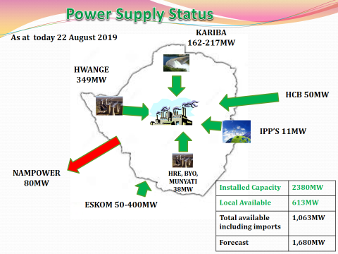

* Recurring droughts have also reduced hydro-electric generation at Kariba Dam.

